%%%%%%%%%%%%%%%%%%%%%%%%%%%%%%%%%%%%%%%%%%%%%%%%%%%%%%%

**Example 5**

In this example, we explore the progression of density across the annulus. In our numerical test, we take the initial data $ρ_{0} =e^{(−30(x^{2} + y^{2})) } + 0.01$. The computational domain is $Ω = \{(x,y)| 1 ≤x^{2} + y^{2} ≤4\}$. The mesh size and time step are set as $tau =1/20000$ and $h =$ 1/16, respectively. We take



%%%%%%%%%%%%%%%%%%%%%%%%%%%%%%%%%%%%%%%%%%%%%%%%%%%%%%%

**Result**

1. **Free energy**

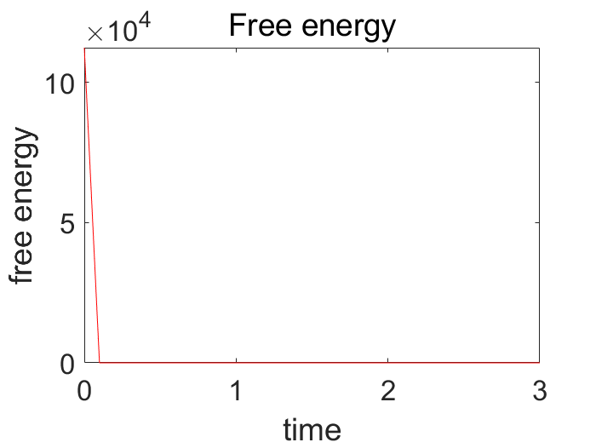

Figure 1 Mesh size(1/16), time step(tau=1/20000)

1. **The total mass**

The total mass at T=0 : 9.425307e-02

The total mass at T=1.000000e-01 : 9.425307e-02

The total mass at T=2.000000e-01 : 9.425307e-02

The total mass at T=3.000000e-01 : 9.425307e-02

The total mass at T=4.000000e-01 : 9.425307e-02

The total mass at T=5.000000e-01 : 9.425307e-02

The total mass at T=6.000000e-01 : 9.425307e-02

The total mass at T=7.000000e-01 : 9.425307e-02

The total mass at T=8.000000e-01 : 9.425307e-02

The total mass at T=9.000000e-01 : 9.425307e-02

The total mass at T=1 : 9.425307e-02

The total mass at T=1.100000e+00 : 9.425307e-02

The total mass at T=1.200000e+00 : 9.425307e-02

The total mass at T=1.300000e+00 : 9.425307e-02

The total mass at T=1.400000e+00 : 9.425307e-02

The total mass at T=1.500000e+00 : 9.425307e-02

The total mass at T=1.600000e+00 : 9.425307e-02

The total mass at T=1.700000e+00 : 9.425307e-02

The total mass at T=1.800000e+00 : 9.425307e-02

The total mass at T=1.900000e+00 : 9.425307e-02

The total mass at T=2 : 9.425307e-02

The total mass at T=2.100000e+00 : 9.425307e-02

The total mass at T=2.200000e+00 : 9.425307e-02

The total mass at T=2.300000e+00 : 9.425307e-02

The total mass at T=2.400000e+00 : 9.425307e-02

The total mass at T=2.500000e+00 : 9.425307e-02

The total mass at T=2.600000e+00 : 9.425307e-02

The total mass at T=2.700000e+00 : 9.425307e-02

The total mass at T=2.800000e+00 : 9.425307e-02

The total mass at T=2.900000e+00 : 9.425307e-02

The total mass at T=3 : 9.425307e-02

1. **Numerical result**

|  |  |  |
| --- | --- | --- |
| rho_h_fill3_0  Figure 2 t = 0 | rho_h_fill3_1  Figure 3 t = 0.05 | rho_h_fill3_4  Figure 4 t =0.2 |
| rho_h_fill3_6  Figure 5 t = 0.3 | rho_h_fill3_10  Figure 6 t = 1 | rho_h_fill3_30  Figure 7 t = 3 |